Software Requirements Specification
for
<Project>
Version 1.0
Prepared by <author>
<organization>
<date created>
Table of Contents
Table of Contents ii
Revision History ii
1. Introduction 1
1.1 Purpose 1
1.2 Document Conventions 1
1.3 Intended Audience and Reading Suggestions 1
1.4 Project Scope 1
1.5 References 1
2. Overall Description 2
2.1 Product Perspective 2
2.2 Product Features 2
2.3 User Classes and Characteristics 2
2.4 Operating Environment 2
2.5 Design and Implementation Constraints 2
2.6 User Documentation 2
2.7 Assumptions and Dependencies 3
3. System Features 3
3.1 System Feature 1 3
3.2 System Feature 2 (and so on) 4
4. External Interface Requirements 4
4.1 User Interfaces 4
4.2 Hardware Interfaces 4
4.3 Software Interfaces 4
4.4 Communications Interfaces 4
5. Other Nonfunctional Requirements 5
5.1 Performance Requirements 5
5.2 Safety Requirements 5
5.3 Security Requirements 5
5.4 Software Quality Attributes 5
6. Other Requirements 5
Appendix A: Glossary 5
Appendix B: Analysis Models 6
Appendix C: Issues List 6

Revision History
Name | Date | Reason For Changes | Version

Introduction

Purpose
The purpose of this document is to define the software requirements for the Wiffleball GameTracker Application, a mobile and server-based system designed to record, manage, and display statistics for organized wiffleball games. This SRS covers the first release of the application, including the mobile client, backend API, and database design.

Document Conventions
- Requirements are written using “shall” statements to indicate mandatory behavior.
- Functional requirements are labeled using the format REQ-x.y.
- Entity and attribute names follow snake_case naming conventions.
- Priority levels are defined as High, Medium, or Low.

Intended Audience and Reading Suggestions
This document is intended for: - Developers implementing the frontend and backend - Instructors/Evaluators assessing system design - Testers verifying system functionality
Readers unfamiliar with the system should begin with Sections 1 and 2. Developers should focus on Sections 3 and 4. Evaluators may prioritize Sections 2, 3, and 5.

Project Scope
The Wiffleball GameTracker Application provides a GameChanger-style experience tailored specifically for wiffleball. The system allows authorized users to start games and log pitch-by-pitch plays while allowing general users to view teams, players, games, and statistics. The goal is to provide accurate stat tracking, structured data storage, and real-time or post-game access to results.

References
- IEEE 830-1998 Software Requirements Specification Standard
- MySQL 8.0 Documentation
- Android Developer Documentation (Kotlin)
- REST API Design Best Practices

Overall Description

Product Perspective
This product is a new, self-contained application inspired by existing baseball stat-tracking platforms but redesigned for the rules and structure of wiffleball. The system consists of a Kotlin-based Android client, a PHP REST API, and a MySQL relational database.

Product Features
Major features include: - Account authentication and role-based access - Team and player management - Game creation and lifecycle management - Pitch-by-pitch play tracking - Automatic stat aggregation - Read-only stat viewing for non-admin users

User Classes and Characteristics
- Admin Users: Authorized scorekeepers who can create games and record plays. Moderate technical proficiency.
- Standard Users: Players or spectators who can view games and statistics. Minimal technical expertise required.

Operating Environment
- Android mobile devices
- Backend hosted on a Linux-based server
- MySQL relational database
- Communication over HTTPS

Design and Implementation Constraints
<Describe any items or issues that will limit the options available to the developers. These might include corporate or regulatory policies; hardware limitations (timing requirements, memory requirements); interfaces to other applications; specific technologies, tools, and databases to be used; parallel operations; language requirements; communications protocols; security considerations; design conventions or programming standards (for example, if the customer’s organization will be responsible for maintaining the delivered software).>

User Documentation
- In-app help tooltips and comments
- API documentation for backend endpoints

Assumptions and Dependencies
- Users have internet access during gameplay
- Android device permissions are granted for network access

System Features

User Authentication and Authorization
<Don’t really say “System Feature 1.” State the feature name in just a few words.>
3.1.1 Description and Priority
Allows users to log in and determines access level. Priority: High
3.1.2 Stimulus/Response Sequences
- User enters login credentials
- System validates credentials via PHP API
- System grants or denies accessibility based on role

3.1.3 Functional Requirements
- REQ-3.1.1: The system shall authenticate users using email and password.
- REQ-3.1.2: The system shall restrict game creation to admin users.
- REQ-3.1.3: The system shall allow non-admin users read-only access.

Game Management

Description and Priority
Admins can create, start, and finalize games. Priority: High

3.2.2 Stimulus/Response Sequences
1. Admin selects teams

2. Admin starts a game

3. System initializes game state

3.2.3 Functional Requirements
- REQ-3.2.1: The system shall allow admins to create a game with two teams.
- REQ-3.2.2: The system shall track game status (not started, in progress, final).
- REQ-3.2.3: The system shall store final scores upon game completion.

Play and Stat Tracking

Description and Priority
Tracks each pitch or play event. Priority: High

3.3.2 Stimulus/Response Sequences

1. Admin records pitch result

2. System updates inning, count, runners, positions

3. System initializes game state

3.3.3 Functional Requirements
- REQ-3.3.1: The system shall record inning and count for each play.
- REQ-3.3.2: The system shall record batter and pitcher for each play.
- REQ-3.3.3: The system shall record play result using a defined result type.

External Interface Requirements

User Interfaces
- Android-based touch interface
- Standard navigation patterns
- Error messages displayed via dialogs

Hardware Interfaces
- Android device touchscreen
- Network interface for server communication

Software Interfaces
- PHP REST API
- MySQL database
- JSON-formatted request/response bodies

Communications Interfaces
- HTTPS over TCP/IP
- RESTful HTTP methods (GET, POST)

Other Nonfunctional Requirements

Performance Requirements
- API responses shall return within 2 seconds under normal load.

Safety Requirements
- REQ-5.2.1: The system shall require explicit user confirmation before any destructive action, including deleting a game, play, team, or player.
- REQ-5.2.2: The system shall restrict delete operations to admin users only.
- REQ-5.2.3: The system shall implement soft deletion for critical entities (games, plays, players), marking records as inactive rather than permanently removing them from the database.

Security Requirements
- Passwords shall be stored using hashing.
- API endpoints shall require authentication tokens.

Software Quality Attributes
<Specify any additional quality characteristics for the product that will be important to either the customers or the developers. Some to consider are: adaptability, availability, correctness, flexibility, interoperability, maintainability, portability, reliability, reusability, robustness, testability, and usability. Write these to be specific, quantitative, and verifiable when possible. At the least, clarify the relative preferences for various attributes, such as ease of use over ease of learning.>

Other Requirements
- Relational database must enforce foreign key constraints.
- System must support multiple games per season.
Appendix A: Glossary
- Play: A single pitch or event in a game
- Admin: User authorized to record games
- API: Application Programming Interface
Appendix B: Analysis Models
Entity Relationship Diagram
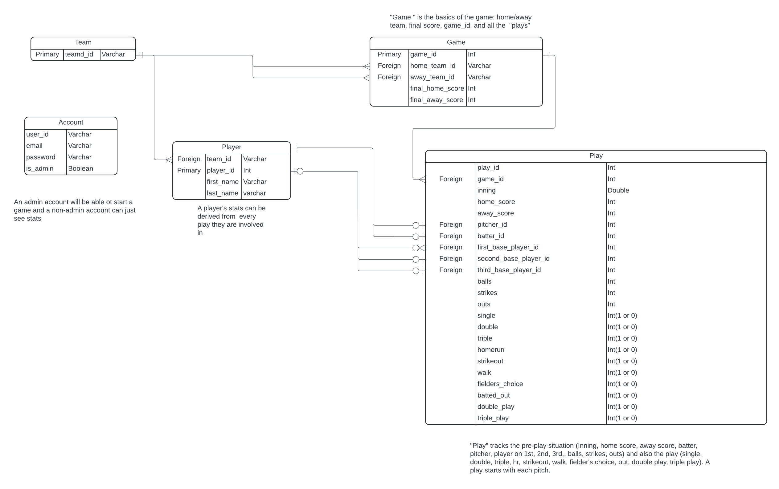Appendix C: Issues List
- Final decision on which statistics to calculate
- Final decision on game recording process, specifically strategy for implementing an “undo” button to delete the previous play.

